**A microcontroller usually comprises of a CPU, ROM, RAM and I/O ports, built within it to execute a single and dedicated task. It has 8kB Flash and 256 bytes of data RAM32 I/O lines Microcontrollers are designed for embedded applications, in contrast to the**[**microprocessors**](http://en.wikipedia.org/wiki/Microprocessor)**used in**[**personal computers**](http://en.wikipedia.org/wiki/Personal_computer)**or other general purpose applications.**

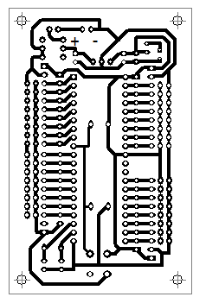 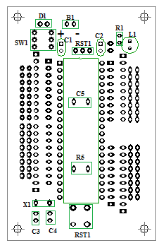

**Layout Component Diagram**

**Component List:-**

|  |  |  |  |  |  |
| --- | --- | --- | --- | --- | --- |
| **Sr no.** | **Abbreviation** | | **Component** | **Value** | **COST** |
| 1 | D1 | | DIODE | 1N4007 | 1 |
| 2 | SW1 | | SWITCH | - | 6 |
| 3 | C1,C5 | | CAPACITOR | 10Uf | 2 |
| 4 | C2 | | CAPACITOR | 100uF | 2 |
| 5 | C3,C4 | | CAPACITOR | 33Pf | 2 |
| 6 | X1 | | CRYSTAL | 11.0592MHz | 12 |
| 7 | RT1 | | REGULATOR | 7805 | 15 |
| 8 | IC1 | | 40 PINS SOCKET(89S52) | - | 20 |
| 9 | L1 | | LED | 3mm | 1 |
| 10 | R1 | | RESISTOR | 270Ω | 1 |
| 11 | R5 | | RESISTOR | 8.2KΩ | 1 |
| 12 | RST1 | | RESET SWITCH | - |  |
| 13 | B1 | | BUG STRIP | - |  |
| 14 | 89S52 | | MICROCONTROLLER | - | 135 |
| 15 | 89V51RD2 | | MICROCONTROLLER | - | 195 |
|  | |